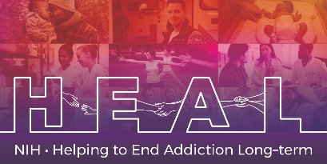

The Current Opioid Misuse Measure (COMM) is Copyrighted.
To access this measure, please contact the author (Dr. Stephen F Butler; sfbutler@inflexxion.com) to obtain a license for this measure

When applying for access, please indicate that you are conducting research as part of the NIH HEAL Initiative:

“Our study is a NIH funded study. We are part of the HEAL Initiative.”

Once you have license permission, please share your email confirmation with HEAL_CDE@hsc.utah.edu for access to the NIH HEAL Initiative’s CDE for this measure.

English and Spanish CRFs are available.

