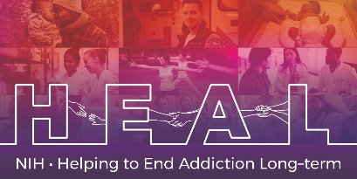

The Edinburgh Postnatal Depression Scale (EPDS) is Copyrighted.
To access this measure, Please register with the Royal College of Psychiatrists to obtain a license for this measure: https://www.rcpsych.ac.uk/about-us/contact-us
When applying for access, please indicate that you are conducting research as part of the NIH HEAL Initiative:
“Our study is a NIH funded study. We are part of the HEAL Initiative.”

Once you have license permission, please share your email confirmation with HEAL_CDE@hsc.utah.edu for access to the NIH HEAL Initiative’s CDE for this measure.

English CRF is available.

