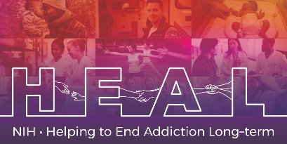

The Hospital Anxiety and Depression Scale (HADS) is Copyrighted.
To access this measure, please obtain permission with permissions@gl-assessment.co.uk
When applying for access, please indicate that you are conducting research as part of the NIH HEAL Initiative:
“Our study is a NIH funded study. We are part of the HEAL Initiative.”

Once you have license permission, please share your email confirmation with HEAL_CDE@hsc.utah.edu for access to the NIH HEAL Initiative’s CDE for this measure.

English CRF is available.

