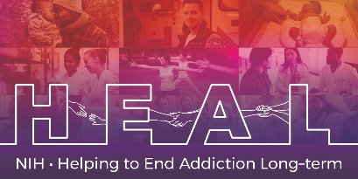

The Mini-International Neuropsychiatric Interview (MINI) is Copyrighted.
To access this measure, Please register at Dr. David Sheehan’s website www.davidvsheehan.org to obtain permission.
When applying for access, please indicate that you are conducting research as part of the NIH HEAL Initiative:

“Our study is a NIH funded study. We are part of the HEAL Initiative.”

Once you have license permission, please share your email confirmation with HEAL_CDE@hsc.utah.edu for access to the NIH HEAL Initiative’s CDE for this measure.

English CRF is available.

