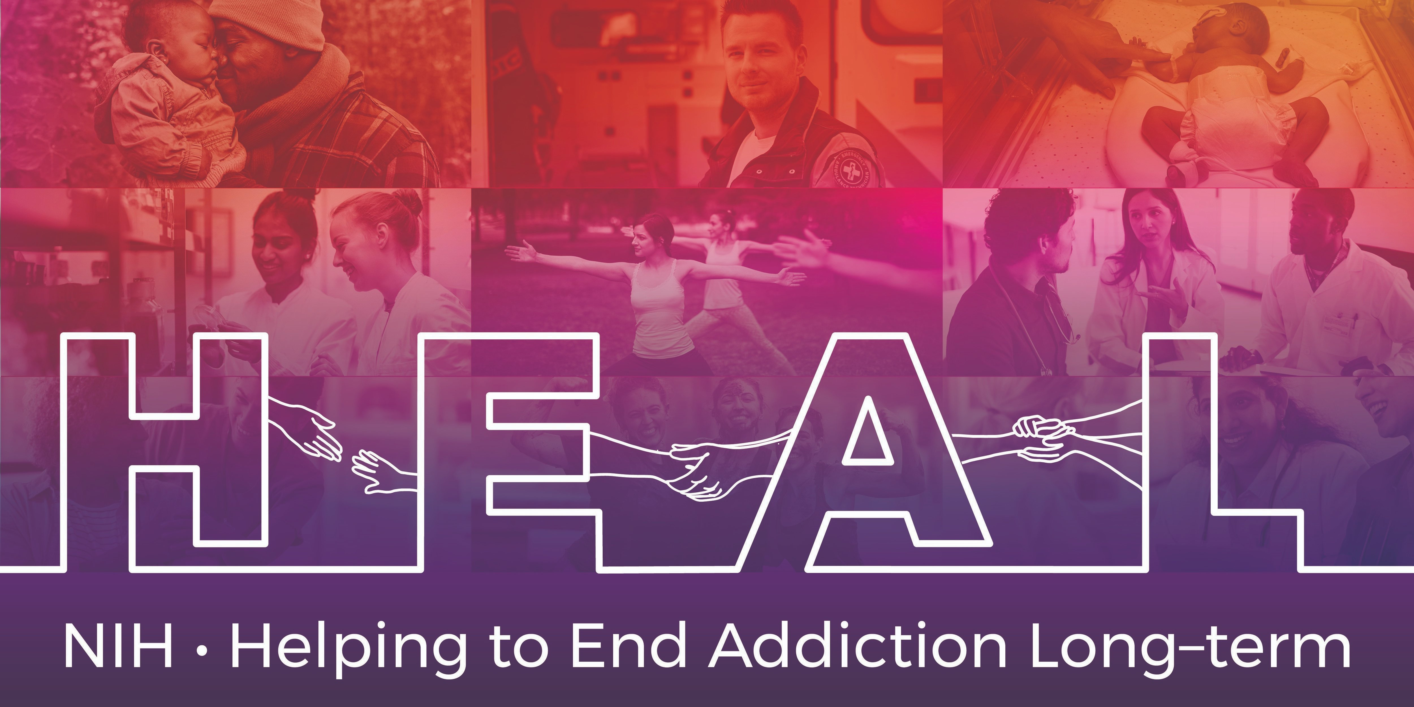
The Pediatric Anesthesia Emergence Delirium Scale- PAED is Copyrighted.
According to the authors, Jerrold Lerman and Nancy Sikich, American Society of Anesthesiologists owns the rights to the article and the questionnaire. To obtain permission:
- Click this link.
- Choose “Get Permissions”.
- Fill out the form and pay the fee, if required.
When applying for access, please indicate that you are conducting research as part of the NIH HEAL Initiative:
“Our study is a NIH funded study. We are part of the HEAL Initiative.”
Once you have permission, please share your email confirmation with HEAL_CDE@hsc.utah.edu for access to the NIH HEAL Initiative’s CDE for this measure.
An English CRF is available for this measure.

