Using the Stool Chart please define the consistency of your stool sample provided to us.

Stool Type (Choose one response that best matches your sample provided)
_1. Type 1 Separate hard lumps, like nuts (hard to pass)
_2. Type 2 Sausage shaped but lumpy
_3. Type 3 Like a sausage but with cracks on the surface
_4. Type 4 Like a sausage or snake, smooth and soft
_5. Type 5 Soft blobs with clear-cut edges
_6. Type 6 Fluffy pieces with ragged edges, a mushy stool
_7. Type 7 Watery, no solid pieces, entirely liquid

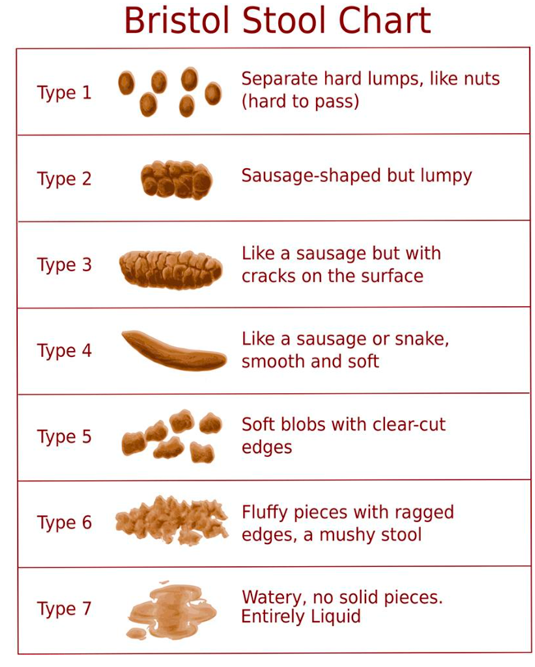
Figure 1. Bristol Stool chart.
Reference
Department of Twin Research & Genetic Epidemiology, King's College London, UK. (n.d.). Twin research for a healthy future. Retrieved September 04, 2020, from https://twinsuk.ac.uk/
TwinsUK is funded by the Wellcome Trust, Medical Research Council, European Union, Chronic Disease Research Foundation (CDRF), Zoe Global Ltd and the National Institute for Health Research (NIHR)-funded BioResource, Clinical Research Facility and Biomedical Research Centre based at Guy’s and St Thomas’ NHS Foundation Trust in partnership with King’s College London.

