Please fill this form only if you HAVE EYE/FACIAL PAIN today or HAVE FILLED THIS FORM BEFORE

1. Please rate the overall severity of your pain today: (0= no pain, 10= worst pain ever)
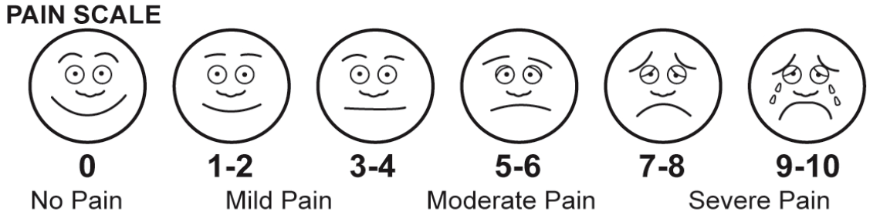
Figure 1. Pain Scale diagram, combining graphical faces, numeric values, and verbal descriptors

2. On the diagram below, please shade the area where you have eye pain, and/or pain in the face and head region.
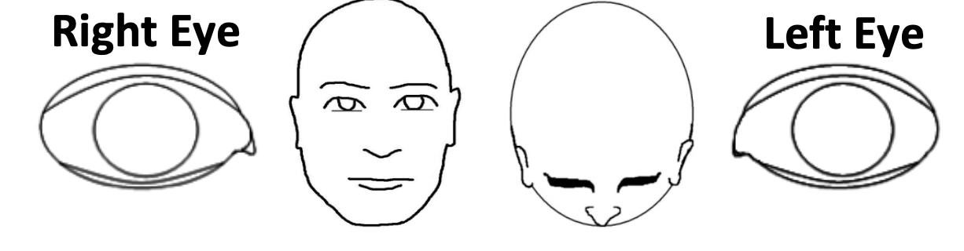
Figure 2. Diagram to show location of eye pain or pain in the face or head.

3. Do you have any longstanding pain elsewhere in your body? _0. No _1. Yes
3a. If yes, please state where:________________

ALL QUESTIONS REFER TO PAIN IN YOUR WORSE EYE. Please mark the level of your eye pain for the following:
Note: questions 4 – 11 are presented as images of a 0 to 10 number line. On the left, before 0, is a smiling face and the words No Pain. On the right, after 10, is a frowning face and the words Severe Pain. Above the line is the time frame. For example:

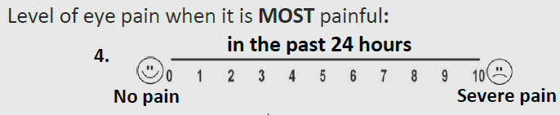
Figure 3. Image showing how questions 4 – 11 are graphically displayed.
EYE PAIN INTENSITY 24 HOURS

4. Level of eye pain when it is MOST painful in the past 24 hours
_ 0 _ 1 _ 2 _ 3 _ 4 _ 5 _ 6 _ 7 _ 8 _ 9 _ 10
0 = no pain 10 = severe pain

5. Level of eye pain when it is LEAST painful in the past 24 hours
_ 0 _ 1 _ 2 _ 3 _ 4 _ 5 _ 6 _ 7 _ 8 _ 9 _ 10
0 = no pain 10 = severe pain

6. Level of eye pain on AVERAGE in the past 24 hours
_ 0 _ 1 _ 2 _ 3 _ 4 _ 5 _ 6 _ 7 _ 8 _ 9 _ 10
0 = no pain 10 = severe pain

EYE PAIN INTENSITY 2 WEEKS

7. Level of eye pain when it is MOST painful in the past 2 weeks
_ 0 _ 1 _ 2 _ 3 _ 4 _ 5 _ 6 _ 7 _ 8 _ 9 _ 10
0 = no pain 10 = severe pain

8. Level of eye pain when it is LEAST painful in the past 2 weeks
_ 0 _ 1 _ 2 _ 3 _ 4 _ 5 _ 6 _ 7 _ 8 _ 9 _ 10
0 = no pain 10 = severe pain

9. Level of eye pain on AVERAGE in the past 2 weeks
_ 0 _ 1 _ 2 _ 3 _ 4 _ 5 _ 6 _ 7 _ 8 _ 9 _ 10
0 = no pain 10 = severe pain

NON-EYE PAIN

Please mark the level of your worst non-eye pain (pain at temples, back of head, cheek area):
10. in the past 24 hours
_ 0 _ 1 _ 2 _ 3 _ 4 _ 5 _ 6 _ 7 _ 8 _ 9 _ 10
0 = no pain 10 = severe pain

11. in the past 2 weeks
_ 0 _ 1 _ 2 _ 3 _ 4 _ 5 _ 6 _ 7 _ 8 _ 9 _ 10
0 = no pain 10 = severe pain

12. Please mark the percentage of time you spend thinking about your non-eye pain (face/head):
Not at all _0% _10% _20% _30% _40% _50% _60% _70% _80% _90% _ 100% All the time

QUALITY OF LIFE (QOL)

Please mark one number that describes how much your pain has interfered with/affected the following:

13. Reading and/or Computer use
Not at all _0 _1 _2 _3 _4 _5 _6 _7 _8 _9 _ 10 Completely
_ N/A

14. Driving and/or Watching TV
Not at all _0 _1 _2 _3 _4 _5 _6 _7 _8 _9 _ 10 Completely
_ N/A

15. General activity (walking, doing house chores)
Not at all _0 _1 _2 _3 _4 _5 _6 _7 _8 _9 _ 10 Completely
_ N/A

16. Mood
Not at all _0 _1 _2 _3 _4 _5 _6 _7 _8 _9 _ 10 Completely
_ N/A

17. Sleep
Not at all _0 _1 _2 _3 _4 _5 _6 _7 _8 _9 _ 10 Completely
_ N/A

18. Enjoying life/Relations with other people
Not at all _0 _1 _2 _3 _4 _5 _6 _7 _8 _9 _ 10 Completely
_ N/A

19. Please circle the percentage of time you spend thinking about your eye pain:
Not at all _0% _10% _20% _30% _40% _50% _60% _70% _80% _90% _ 100% All the time

AGGRAVATING FACTORS

Please mark how much your pain is increased when exposed to:

20. Wind, dry air, heat, air conditioning
No change _0% _10% _20% _30% _40% _50% _60% _70% _80% _90% _ 100% Severe increase

21. Volatile chemicals (cleaning agents, fumes, cosmetic fragrances)
No change _0% _10% _20% _30% _40% _50% _60% _70% _80% _90% _ 100% Severe increase

ASSOCIATED FACTORS
Please mark how often your eye pain is accompanied by the following symptoms:

22. Redness
Never _0% _10% _20% _30% _40% _50% _60% _70% _80% _90% _ 100% All the time

23. Burning
Never _0% _10% _20% _30% _40% _50% _60% _70% _80% _90% _ 100% All the time

24. Sensitivity to light
Never _0% _10% _20% _30% _40% _50% _60% _70% _80% _90% _ 100% All the time

25. Tearing
Never _0% _10% _20% _30% _40% _50% _60% _70% _80% _90% _ 100% All the time

SYMPTOM RELIEF
Please mark how much pain relief you have experienced since the last visit:

26. Eye pain
No relief _0% _10% _20% _30% _40% _50% _60% _70% _80% _90% _ 100% Complete relief
_ N/A

27. Non-eye pain (face/head)
No relief _0% _10% _20% _30% _40% _50% _60% _70% _80% _90% _ 100% Complete relief
_ N/A

Notes:
SCORING: Calculate the mean of scores for each of the 7 categories above by dividing the sum of scores per box by the number of questions answered for that box. List each individual score below. *Divide all percentage values (Qs. 19-27) by 10 (for example, 0% = 0, 50%= 5, 100%= 10) before calculating scores.

Eye pain intensity 24 hrs (Qs. 4-6): (sum of scores for Qs. 4-6 ÷ number of questions answered for Qs. 4-6)
Eye pain intensity 2 weeks (Qs. 7-9): (sum of scores for Qs. 7-9 ÷ number of questions answered for Qs. 7-9)
Non-eye pain (Qs. 10-12): (sum of scores for Qs. 10-12 ÷ number of questions answered for Qs. 10-12)
Quality of Life (QOL)* (Qs. 13-19): (sum of scores for Qs. 13-19 ÷ number of questions answered for Qs. 13-19)
Aggravating factors* (Qs. 20-21): (sum of scores for Qs. 20-21 ÷ number of questions answered for Qs. 20-21)
Associated factors* (Qs. 22-25): (sum of scores for Qs. 22-25 ÷ number of questions answered for Qs. 22-25)
Symptom relief* (Qs. 26-27): (sum of scores for Qs. 26-27 ÷ number of questions answered for Qs. 26-27)

Reference:
Qazi Y, Hurwitz S, Khan S, Jurkunas UV, Dana R, Hamrah P. Validity and Reliability of a Novel Ocular Pain Assessment Survey (OPAS) in Quantifying and Monitoring Corneal and Ocular Surface Pain. Ophthalmology. 2016;123(7):1458-1468. doi:10.1016/j.ophtha.2016.03.006

